create or replace procedure raise_sal(p_id in emplo.empid%TYPE,p_percent in number) is

begin

update emplo set netsal=netsal*(1+p_percent/100) where empid=p_id;

end;

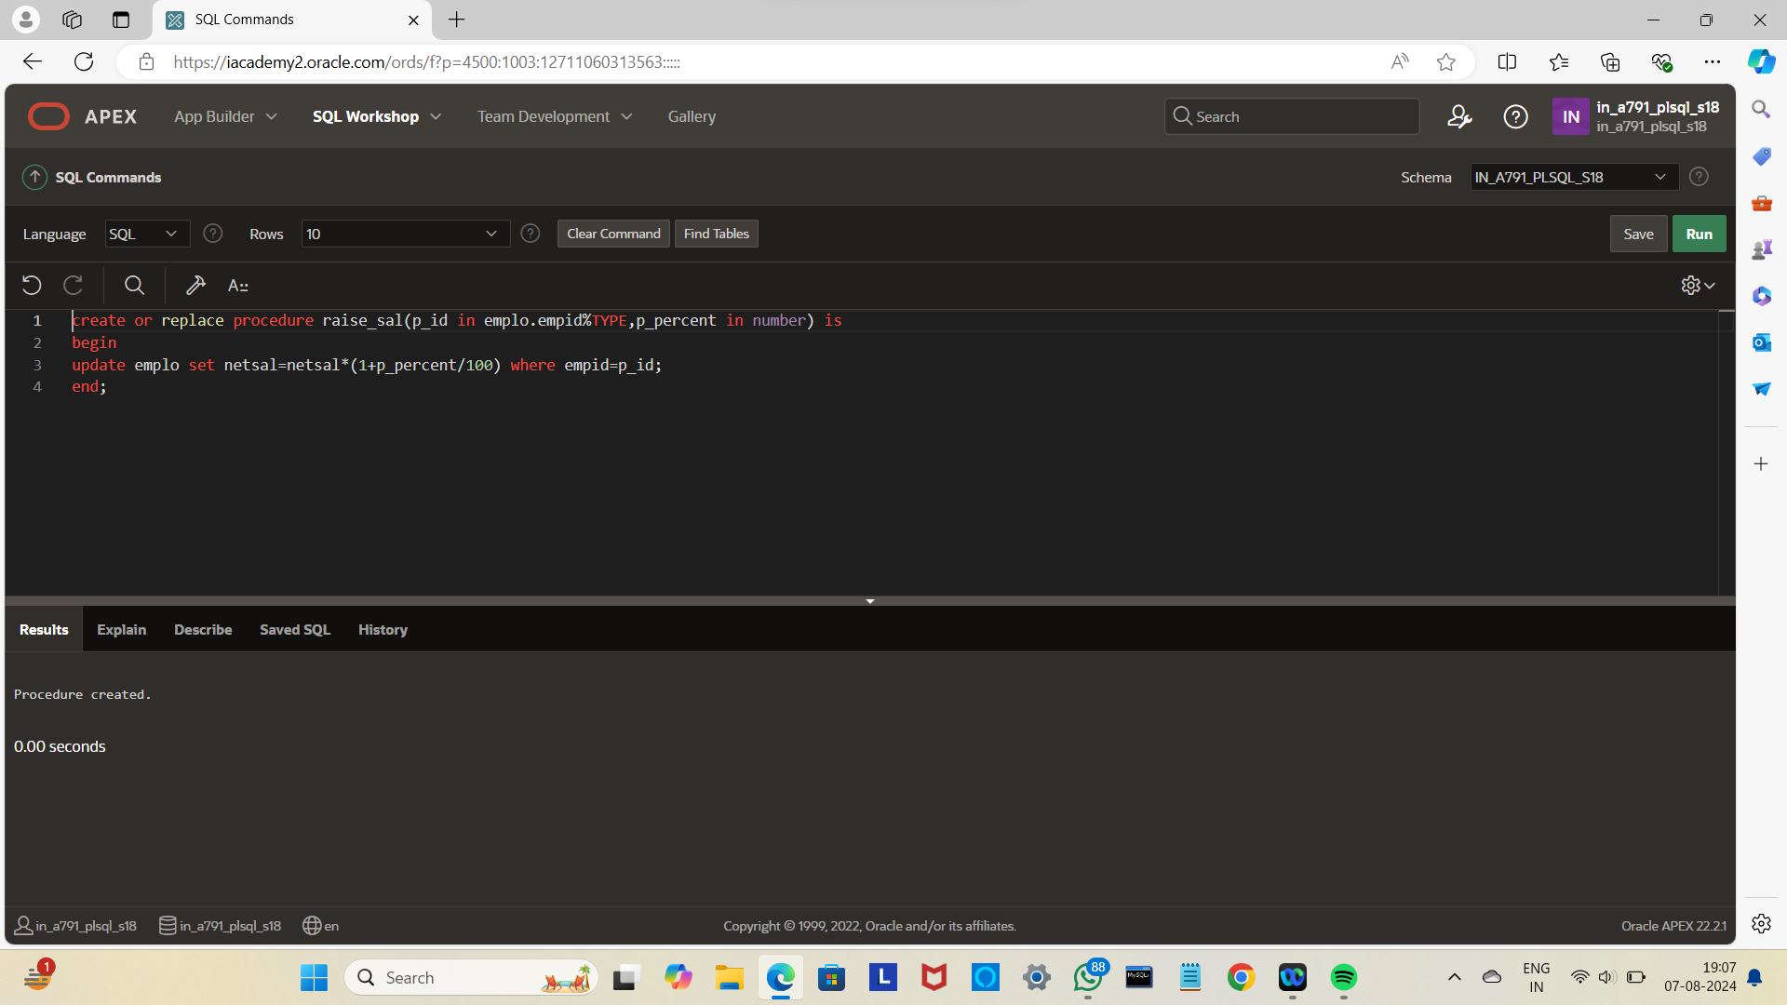

begin

raise_sal(103,10);

end;

/

Select*from emplo;

